**Adam Roberts**

8/18/2019

**Full macro enables excel doc:**

Excel file available for download via google drive here:

<https://drive.google.com/file/d/1r0SN_nR6sIovgTALuqCpVzTsKnhBK6Co/view?usp=sharing>

**Screenshots:**

Screenshots below are for the moderate + hard portion of the homework. I had to calculated columns in the summary table that weren’t explicitly asked for in the homework – “start of year open” and “end of year close”. I kept these because I thought they were interesting rather than commenting them out.

**2014 Results**

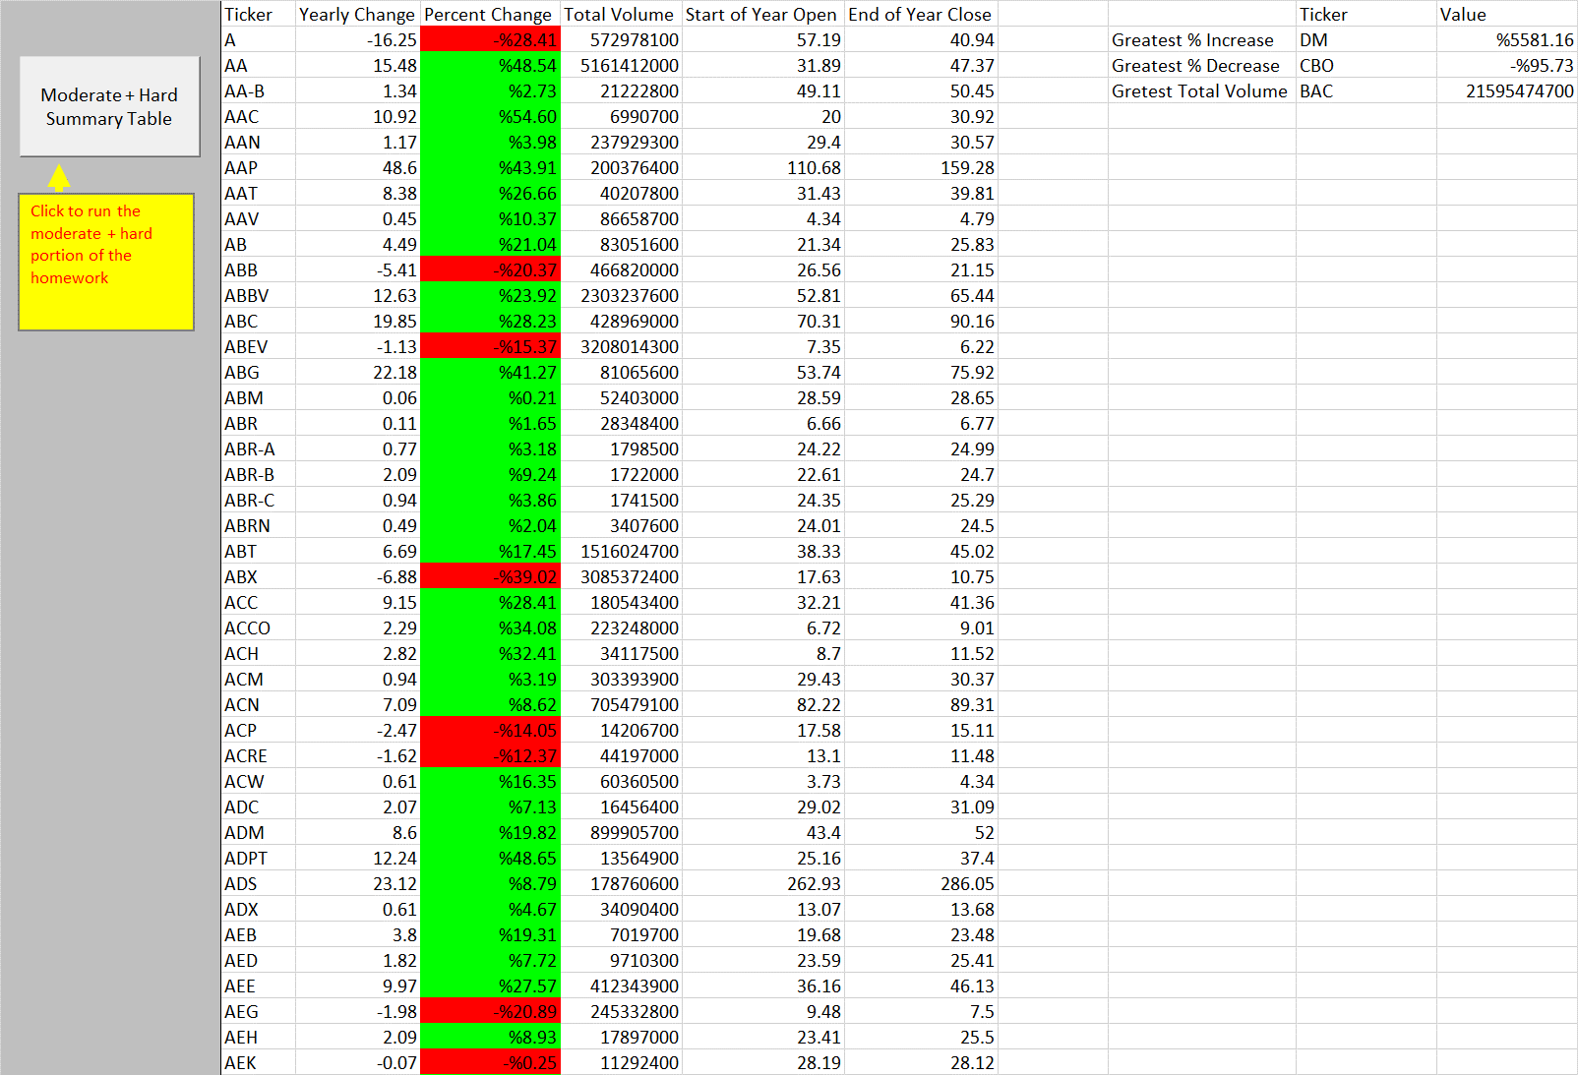

**2015 Results**

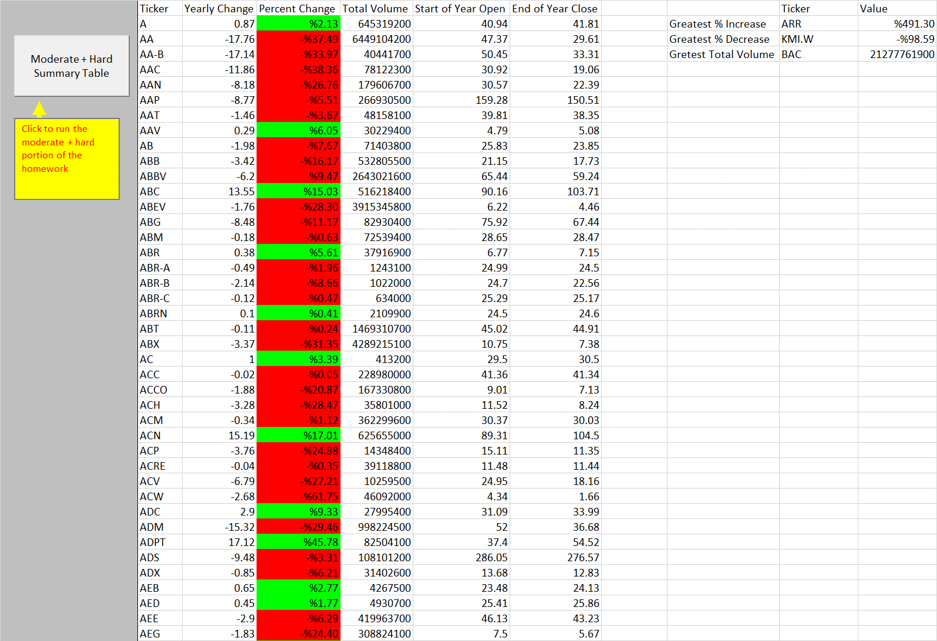

**2016 Results**

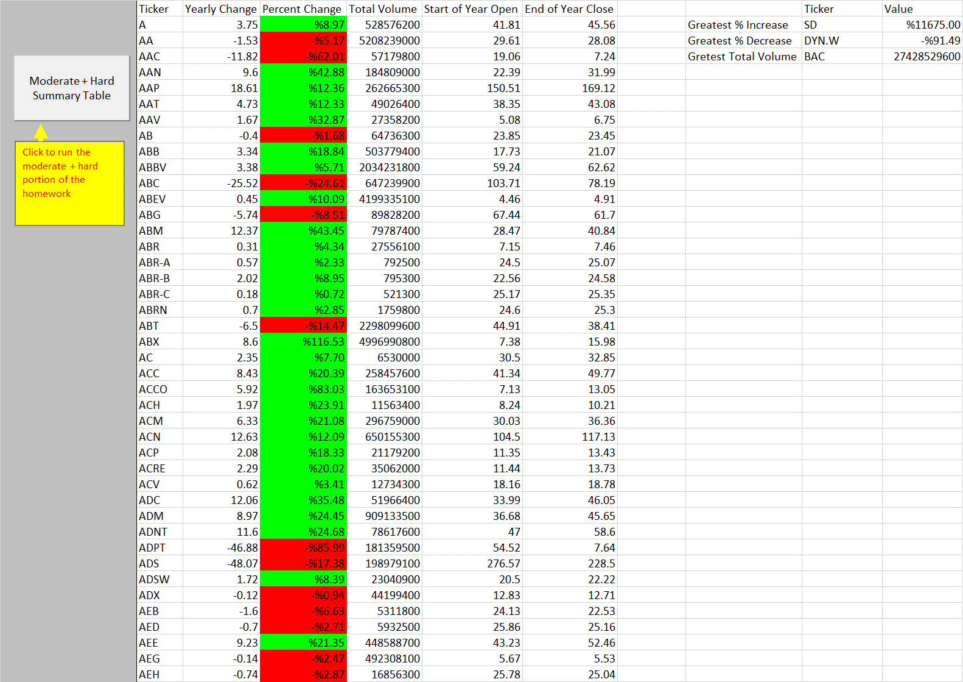

**Code:**

**“Easy” Portion of Homework:**

Sub stock_basic()

'variable for holding stock ticker

Dim ticker As String

'variable for holding stock volume

Dim stock_volume As Double

stock_volume = 0

'track row of summary table

Dim summary_table_row As Integer

summary_table_row = 2

'identify last row

lastrow = Cells(Rows.Count, 1).End(xlUp).Row

'loop through stocks

For i = 2 To lastrow

'check for change in ticker value

If Cells(i, 1).Value <> Cells(i + 1, 1).Value Then

'set the ticker name

ticker = Cells(i, 1).Value

'add to volume total

stock_volume = stock_volume + Cells(i, 7).Value

'add stock ticker to summary table

Range("J" & summary_table_row).Value = ticker

'add total volume to summary table

Range("K" & summary_table_row).Value = stock_volume

'increment up the summary table row by 1

summary_table_row = summary_table_row + 1

'reset the stock volume total

stock_volume = 0

'no change in ticker from cell to cell

Else

'add to the volume total

stock_volume = stock_volume + Cells(i, 7)

End If

Next i

'populate the summary table header rows

Range("J1").Value = "Ticker"

Range("K1").Value = "Total Volume"

End Sub

**“Moderate” & “Hard” Portion of Homework:**

Sub stock_moderate()

'variable for holding stock ticker

Dim ticker As String

'variable for holding stock volume

Dim stock_volume As Double

stock_volume = 0

'varialble for start of year open and end of year close and change metrics

Dim year_open As Double

Dim year_close As Double

Dim net_change As Double

Dim percent_change As Double

'track row of summary table

Dim summary_table_row As Integer

summary_table_row = 2

'identify last row

lastrow = Cells(Rows.Count, 1).End(xlUp).Row

'loop through stocks

For i = 2 To lastrow

'check if ticker value just changed

If Cells(i, 1).Value <> Cells(i - 1, 1).Value Then

'establish the year open

year_open = Cells(i, 3).Value

'add year open to summary table

Range("R" & summary_table_row).Value = year_open

'check if ticker value about to change

ElseIf Cells(i, 1).Value <> Cells(i + 1, 1).Value Then

'set the ticker name

ticker = Cells(i, 1).Value

'add to volume total

stock_volume = stock_volume + Cells(i, 7).Value

'add stock ticker to summary table

Range("N" & summary_table_row).Value = ticker

'add total volume to summary table

Range("Q" & summary_table_row).Value = stock_volume

'establish the year close

year_close = Cells(i, 6).Value

'add year close to summary table

Range("S" & summary_table_row).Value = year_close

'calculate net change

net_change = year_close - year_open

'add net_change to summary table

Range("O" & summary_table_row).Value = net_change

'calculate percent change accomodating for when the open is zero

If year_open <> 0 Then

percent_change = (year_close / year_open) - 1

'Only add percent change to tickers that had an opening value <> 0

Range("P" & summary_table_row).Value = percent_change

Range("P" & summary_table_row).NumberFormat = "%0.00"

'format cells based on positive or negative change

If percent_change > 0 Then

Range("P" & summary_table_row).Interior.Color = vbGreen

ElseIf percent_change < 0 Then

Range("P" & summary_table_row).Interior.Color = vbRed

Else

Range("P" & summary_table_row).Interior.Color = vbWhite

End If 'ends the color formatting if statement

End If 'ends the accomodating for zero, divided by zero problem

'**STEPS TO RESET COUNTERS**

'increment up the summary table row by 1

summary_table_row = summary_table_row + 1

'reset the stock volume total

stock_volume = 0

'no change in ticker from cell to cell, keep running sum of stock_volume

Else

'add to the volume total

stock_volume = stock_volume + Cells(i, 7)

End If

Next i

'populate the summary table header rows

Range("N1").Value = "Ticker"

Range("O1").Value = "Yearly Change"

Range("P1").Value = "Percent Change"

Range("Q1").Value = "Total Volume"

Range("R1").Value = "Start of Year Open"

Range("S1").Value = "End of Year Close"

'******

'Hard portion

'solution will also be able to return the stock with the "Greatest % increase", "Greatest % Decrease" and "Greatest total volume"

'decided to loop through summary table as opposed to embedding in existing loop (which may be possible)

'******

'create varaibles for "leaders" summary table

Dim largest_growth As Double

Dim largest_decline As Double

Dim most_volume As Double

Dim growth_ticker As String

Dim decline_ticker As String

Dim most_volume_ticker As String

'set starting values for each variable, this is done in case the first row is a leader in any category

largest_growth = Range("P2")

largest_decline = Range("P2")

most_volume = Range("Q2")

growth_ticker = Range("N2")

decline_ticker = Range("N2")

most_volume_ticker = Range("N2")

'identify last row of summary table

lastrowsummary = Cells(Rows.Count, 14).End(xlUp).Row

'loop through summary table to get each leader in metric categories

For j = 2 To lastrowsummary

'find out if we get a new largest growth value

If Cells(j, 16) > largest_growth Then

largest_growth = Cells(j, 16).Value

growth_ticker = Cells(j, 14).Value

End If

'find out if we get a new largest decline value

If Cells(j, 16) < largest_decline Then

largest_decline = Cells(j, 16).Value

decline_ticker = Cells(j, 14).Value

End If

'find out if we get a new largest volume

If Cells(j, 17) > most_volume Then

most_volume = Cells(j, 17).Value

most_volume_ticker = Cells(j, 14)

End If

Next j

'Insert labels

Range("U2").Value = "Greatest % Increase"

Range("U3").Value = "Greatest % Decrease"

Range("U4").Value = "Gretest Total Volume"

Range("V1").Value = "Ticker"

Range("W1").Value = "Value"

'insert tickers

Range("V2").Value = growth_ticker

Range("V3").Value = decline_ticker

Range("V4").Value = most_volume_ticker

'insert values, change growth/decline to percentages

Range("W2").Value = largest_growth

Range("W2").NumberFormat = "%0.00"

Range("W3").Value = largest_decline

Range("W3").NumberFormat = "%0.00"

Range("W4").Value = most_volume

'friendly message the the TA checking this :)

MsgBox ("Thanks for looking at my homework have a nice day!")

End Sub